CSC-203L: Computer Networks Lab
OEL Report



Submitted By:

Muhammad Arslan | 2024-CS-632
Afaaq Anwar | 2024-CS-603
Taimoor Ali | 2024-CS-609
Ahsan Shakeel | 2024-CS-638

Submitted To:
Ms. Ghazala

Dated:
January 8, 2026

Department of Computer Science
University of Engineering and Technology Lahore, New Campus
Table of Contents
University Multi-Campus Network Design 3
1. Project Overview 3
1.1 Problem Statement 3
1.2 Objectives 3
2. Network Design 3
2.1 Topology Description 3
2.2 Hardware Specifications 4
2.3 Hardware Requirements 4
2.4 Diagrammatic Representation 5
3. Network Configuration 6
3.1 IP Addressing Scheme (VLSM) 6
3.1.1 Main Campus 6
3.1.2 Kala Shah Kaku Campus 6
3.1.1 RCET Campus 6
3.2 Configurations 6
3.2.1 Switch 6
3.2.2 Routers 7
3.2.3 Server 7
3.4 Services Configuration 7
4. Security Implementation 8
4.1 ACL (Access Control Lists) 8
5. Testing and Validation 8
5.1 Test Cases 8
Test Case 1: Inter-Campus Connectivity 8
Test Case 2: Web Server Access 9
Test Case 3: FTP Secure 9
Test Case 4: Verify Traceroute 10
Test Case 5: Inter-VLAN Connectivity 10
6. Conclusion 11

University Multi-Campus Network Design

1. Project Overview

1.1 Problem Statement
The objective of this project is to design and implement a robust, scalable university network connecting multiple sub-campuses (Main Campus & l two sub-campuses). Each campus comprises multiple departments (Computer Science, Electrical Engineering, Administration) and a dedicated server room. The design must utilize Cisco Packet Tracer to simulate the network, ensuring high availability, redundancy, and security.
The network must support:
- Core services hosted in a central server room.
- VLAN implementation for traffic isolation.
- Inter-campus routing using redundancy to prevent single points of failure.
- Secure internet connectivity via an ISP.

1.2 Objectives
- Topology Design: Implement a star-based multi-campus border routers connected to a central router
- Internal Sub-Campus Architecture: Each sub-campus utilizes Layer 3 switches to perform high-speed inter-VLAN routing between departments. These switches connect to internal routers that handle routing between specific departmental units and the wider campus network.
- Connectivity: Establish communication between campuses using border routers to a central router using Static Routing.
- VLAN Implementation: Segregate traffic using VLANs
  - Computer Science Department (VLAN 10)
  - Electrical Engineering Department (VLAN 20
  - Administration (VLAN 30)
and perform Inter-VLAN routing.
- Service Deployment: Configure essential network services including HTTP, Email (SMTP/POP3), DNS, and FTP.
- Security: Apply Access Control Lists (ACLs) to restrict unauthorized access.
- Redundancy: Ensure no single point of failure for inter-campus communication using multiple border routers.

2. Network Design

2.1 Topology Description
The network follows a hierarchical star topology:
- Core Layer: Connects all campuses via an ISP cloud/backbone.
- Distribution/Border Layer: Dedicated border routers at each sub-campus handle inter-campus traffic via BGP.
- Access Layer: Layer 3 switches routing internal VLAN traffic and connecting end devices.

2.2 Hardware Specifications
- Routers: Cisco 2911 (Supports necessary Interface modules for Serial/Gigabit connections).
- Switches: Cisco 3560 (Layer 3) for Core/Distribution; Cisco 2960 for Access.
- Servers: Generic PT Servers for DNS, Web, Email, and FTP.

2.3 Hardware Requirements
Device Type | Quantity | Role
Routers | 14 | 1 Per Dept. Border Routers, 3 Campus Routers, 1 Central Routers
Layer 3 Switch | 3 | Layer 3 Switches for server rooms.
Access Switch | 33 | For connecting PCs
PCs | 90 | 10 per department (CS, EE, Admin)
Servers | 24 | Web, Email, DNS, FTP
Wireless | 6 | Access Points for mobile connectivity

2.4 Diagrammatic Representation

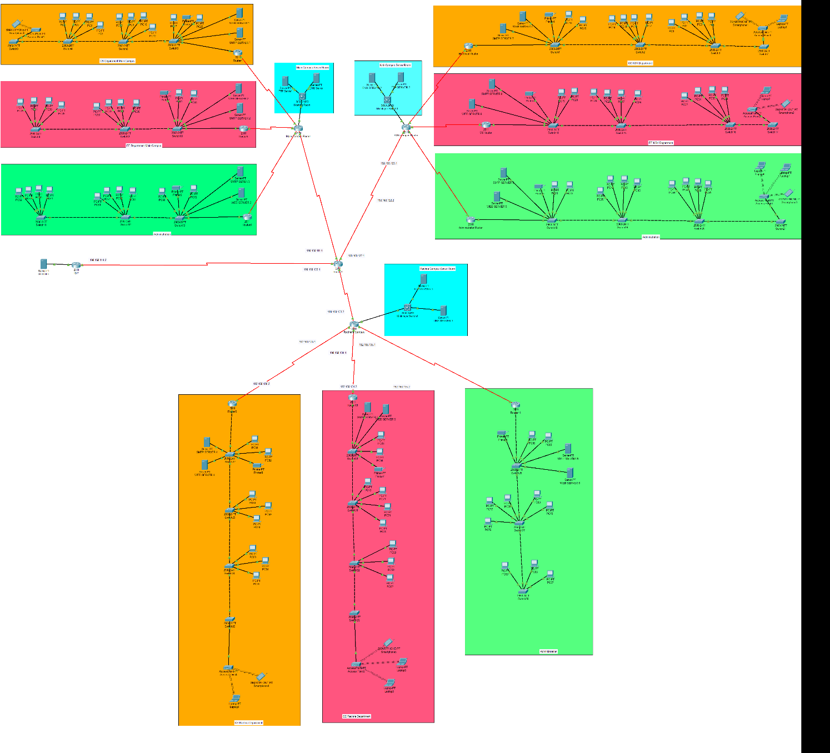

3. Network Configuration

3.1 IP Addressing Scheme (VLSM)
We utilize the private IP block 192.168.0.0/ subdivided for each campus to ensure efficient address allocation.

3.1.1 Main Campus
Dept. Name | VLAN ID | Network Address | Subnet Mask | Gateway
Computer Science | VLAN 10 | 192.168.1.0 | 255.255.255.0 | 192.168.1.1
Electrical Eng. | VLAN 20 | 192.168.2.0 | 255.255.255.0 | 192.168.2.1
Administration | VLAN 30 | 192.168.3.0 | 255.255.255.0 | 192.168.3.1

3.1.2 Kala Shah Kaku Campus
Dept. Name | VLAN ID | Network Address | Subnet Mask | Gateway
Computer Science | VLAN 10 | 192.168.10.0 | 255.255.255.0 | 192.168.10.1
Electrical Eng. | VLAN 20 | 192.168.20.0 | 255.255.255.0 | 192.168.20.1
Administration | VLAN 30 | 192.168.30.0 | 255.255.255.0 | 192.168.30.1

3.1.1 RCET Campus
Dept. Name | VLAN ID | Network Address | Subnet Mask | Gateway
Computer Science | VLAN 10 | 192.168.60.0 | 255.255.255.0 | 192.168.60.1
Electrical Eng. | VLAN 20 | 192.168.70.0 | 255.255.255.0 | 192.168.70.1
Administration | VLAN 30 | 192.168.80.0 | 255.255.255.0 | 192.168.80.1

3.2 Configurations

3.2.1 Switch
Switch> enable
Switch#configure terminal
Switch(config)#interface fastethernet 0/1
Switch(config-if)#switchport access vlan 10
Switch(config-if)#exit
Switch(config)#interface fastethernet 0/2
Switch(config-if)#switchport access vlan 20
Switch(config-if)#exit
Switch(config)#interface fastethernet 0/3
Switch(config-if)#switchport access vlan 30
Switch(config-if)#exit
Switch(config)#exit

3.2.2 Routers
Router>enable
Router#
Router#configure terminal
Enter configuration commands, one per line. End with CNTL/Z.
Router(config)#interface Serial0/0/0
Router(config-if)#ip address 192.168.100.1 255.255.255.252
CS_Router(config-if)#exit
CS_Router(config)#interface GigabitEthernet0/2
Router(config-if)#ip address 192.168.10.1 255.255.255.0
CS_Router(config-if)#exit
Router(config-if)#no shutdown

3.2.3 Server
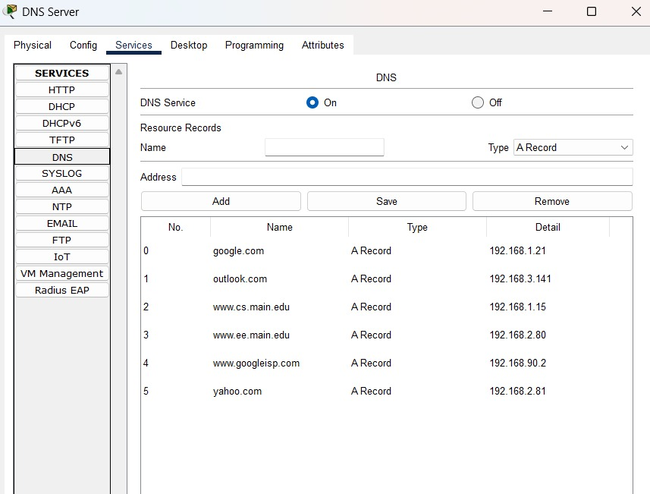

3.4 Services Configuration
- Web Server (HTTP): Hosts the university portal. Accessible to all VLANs. Web server page edited to display "Welcome to CS Dept".
- Email Server: Standard SMTP/POP3 service for internal communication.
- DNS Server: Resolves www.university.edu to the Web Server IP.
- FTP Server: File storage. Restricted to Admin and Faculty VLANs.
- DNS: www.uet.edu.pk to the Web Server IP.

4. Security Implementation

4.1 ACL (Access Control Lists)
Restrict Admin Access Requirement: Admin (Sub-Campus 3) cannot access Web Server in CS (Sub-Campus 1).
access-list 100 deny tcp 192.168.4.128 0.0.0.63 host 192.168.2.10 eq 80
access-list 100 permit ip any any
interface GigabitEthernet0/0
ip access-group 100 in

5. Testing and Validation

5.1 Test Cases

Test Case 1: Inter-Campus Connectivity
Objective: Verify connectivity between Sub-Campus 1 and Sub-Campus 2.
Method: Ping from PC in CS Dept (Sub-Campus 1) to PC in EE Dept (Sub-Campus 2).
Result: Success.

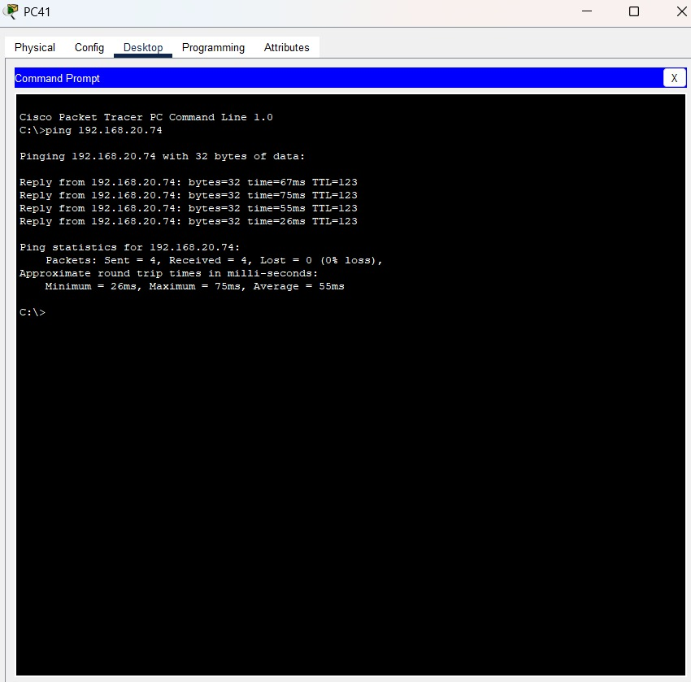

Test Case 2: Web Server Access
Objective: Verify HTTP access from end devices.
Method: Open Web Browser on Laptop and navigate to www.uet.edu.pk.
Result: Success. The default page loads correctly.
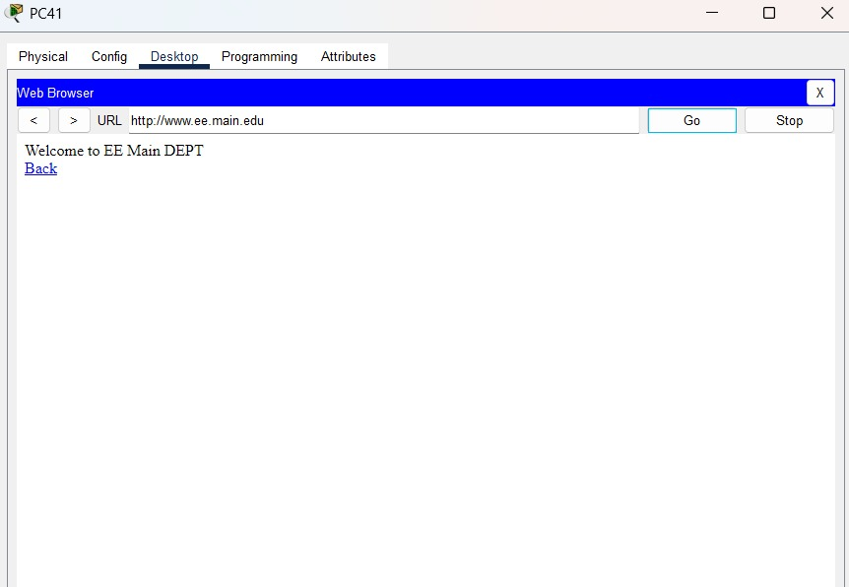

Test Case 3: FTP Secure
Objective: Verify one Campus 1 Admin cannot access the ftp server of another Campus 2.
Method: Open CLI on PC and input command ftp 192.168.112.4
Result: Request Timed Out
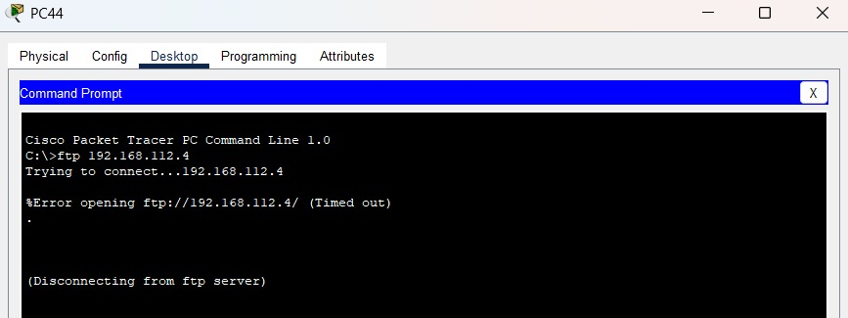

Test Case 4: Verify Traceroute
Objective: Traceroute one Campus 1 to another Campus 2.
Method: Open CLI on PC and input command tracert 192.168.20.74
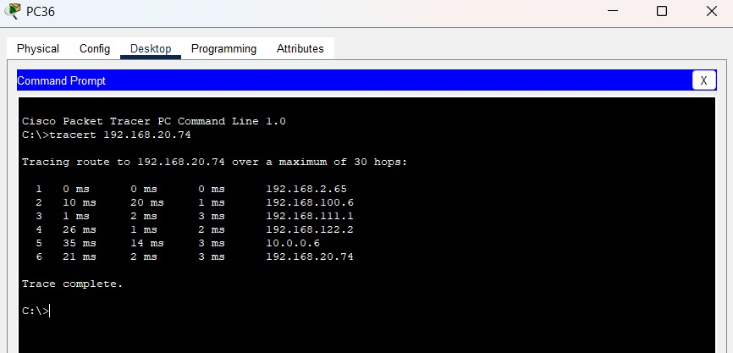
Result: Success

Test Case 5: Inter-VLAN Connectivity
Objective: Verify connectivity between VLAN 10 and VLAN 20 of a Campus.
Method: Ping from PC in CS Dept (Sub-Campus 1) to PC in EE Dept (Sub-Campus 2).
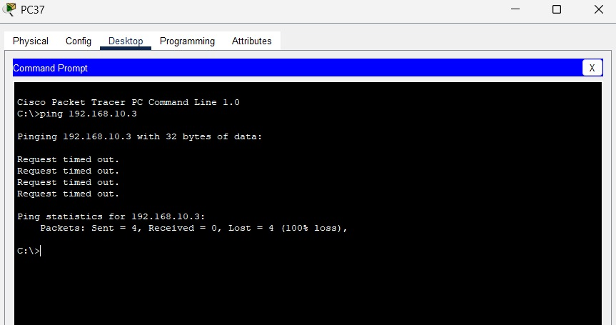
Result: Request Time Out

6. Conclusion
The designed network successfully meets all Open-Ended Lab requirements. It integrates a scalable Multi-Campus architecture with Static routing, robust Virtual Local Area Networks (VLANs) provide essential network isolation, segmentation, and essential services (DNS, HTTP, Email, FTP). This design is ready for simulation and future physical deployment. he simulation in Cisco Packet Tracer confirms that the university network is robust, scalable, and ready for deployment.


